Darwin’s Finches

Problem
Your population of birds begins on a large island, where food is plentiful in a variety of shapes and sizes. There are two different traits for beak shape – large and scooped (Spoon Beak), and sharp and narrow (tweezers). A volcano devastates the island and all its vegetation. The population scatters to other islands nearby. Each of the new islands has limited food types and different environments. One island has rolling hills, where large nuts fall to the ground. The second island has a rocky landscape where small seeds fall into crevices and cracks in the rocky landscape.

Question
How will your population of finches change on the island?

Procedure
TIMER: times each “feeding session” for 10 seconds each.
RETRIEVER: collects “food” for 10 seconds with his/her “beak” (Spoon Beak, Flat Beak).
RECORDER: records the number of food units collected in the 10 second period.
CALCULATOR: calculates the numbers collected for the next generation (if there are three people in the group, everyone does this job)

1ST GENERATION:
- The timer will measure 10 seconds for the retriever to collect food with the Spoon Beak
- The retriever collects as many pieces of food as possible in the 10 second time period.
- The recorder counts the number of food units collected and records it in the first column of 1st generation.
- Return all food units to the container where they were collected.
- Repeat #1-3 with the Flat Beak
- For each food unit collected, they will reproduce that many offspring. Add together columns 1 and 2 to get column 3.
- Calculate the total number of individuals in the population of both beaks, and determine the percentage of each type of beak.
- Follow the arrows to copy column 3 into the second generation.
2ND GENERATION
- Repeat #1-8 for the second generation
3RD GENERATION
- Repeat #1-8 for the third generation
4TH GENERATION
- Repeat #1-8 for the fourth generation

Name Date

Hypothesis
If the finches migrate to rocky islands, then

Data
Beak | # of food units collected | # in population that moved to the island | # in population after reproduction | % of population
Spoon Beak | 1 X | 10 | = 10 | 50%
Flat Beak | 1 X | 10 | = 10 | 50%

1st generation

Beak | # of food units collected | # in population that moved to the island | # in population after reproduction | % of population
Spoon Beak | X | 10 | =
Flat Beak | X | 10 | =
2nd generation
Beak | # of food units collected | # in population from 1st generation | # in population after reproduction 2nd generation | % of population
Spoon Beak | X |  | =
Flat Beak | X |  | =
3rd generation
Beak | # of food units collected | # in population from 2nd generation | # in population after reproduction 3rd generation | % of population
Spoon Beak | X |  | =
Flat Beak | X |  | =
4th generation
Beak | # of food units collected | # in population from 3rd generation | # in population after reproduction 4th generation | % of population
Spoon Beak | X |  | =
Flat Beak | X |  | =

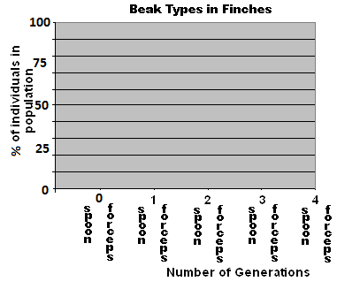

Analysis and conclusion
Write a paragraph (6 sentences) describing the results and conclusions of the experiment.
1) What does the graph tell you about the two types of beaks in the population? 2) What happened during the experiment that caused one beak to be a different number than the other beak? 3) Did you make any mistakes or run into problems during data collection? 4) Restate the hypothesis. 5) Did the data support or contradict your hypothesis? 6) How would you change or extend the experiment if you were to repeat it?

